**React Exercise (5 Days)**

It’s expected that you’ve already completed Phase 1 and done with checklist of React Framework which is part of Phase 2. Now during this exercise you have to convert the app which you would have created in Phase 1 exercise to a SPA (Single Page Application) using React Framework. Make sure you are using all the concepts you’ve learnt during the tutorials like React Router, React Query, Material UI etc.

There is a minor update for this application, this time gallery will not have the static images, instead you will be using an external API to fetch list of images to render on gallery page. Here are the details of the API you can use:

API: <https://picsum.photos/v2/list>

Response structure:

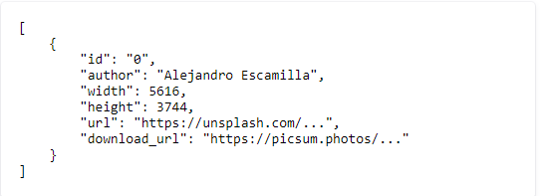

This will be the list of images with metadata which you can use to iterate and render images in gallery page using `download_url` field value.

Make sure you are using React Query to call the API and storing images in React query cache. Until the images are loading, you have to display a MUI loader using: <https://mui.com/material-ui/react-progress/>.

Once images are loaded, hide the loader, render the images in same design which you developed in Phase 1 exercise.